Team and Project Plan
  - Portfolio task 1
Unit code: COS40005
Unit Name: Computing Technology Project A
Submission date: 26th September 2025

Student Name | Student Id | Description of contribution in team and project planning
Eddie Pui Yung Yew | 104386199 | Tasked on use case diagram, product backlog, quality plan and solution approach (AI).
Julian Chet Shiang JEE | 102772505 | Engaged in solution approach (Software Development, Data Science), architecture diagram and process flow diagram.
Tsung Yin NG | 102772686 | Evaluated deliverables and initial release, solution approach (Cyber Security).
Yee Von LOW | 102774187 | Focused on teamwork roadmap, document management, risk mitigation, and solution approach (Software Development).
Zhe Hong VOONG | 102785862 | Explained problem statement, scopes, stakeholder and solution approach (AI).
Ryan NG Hoe Kuene | 102784513 | Engaged in project timeline, high-level requirements and solution approach (Cyber Security).

Acknowledgment of Country
All the members are from Malaysia

PART 1 Team Code of Conduct

Team profile
Table 1: Team Profile
Student name | Technical skills | Soft skills | Communication | Teamwork | Other
Eddie Pui Yung Yew | Experienced in Machine Learning on classification model with framework such as TensorFlow | Manage project organization for the team.  Provide deadline for the tasks.  Help team members to solve the problem when they are facing problems.  Ensure the quality of the task is in good condition | Face to Face, WhatsApp, Teams, Discord
Julian Chet Shiang JEE | Proficient in data visualization using D3.js, frontend and backend for mobile and web applications development using some programming languages (JavaScript, React.js, Next.js, PHP). Engaged in some Artificial Intelligence workloads (path finding agent training model) and some general concepts about image classification training methods such as Keras. | Manage project environment for team, help team members to assign tasks or assist if workload is overwhelming.  Manage communication and meetings with team members for clients.  Provide vision for the team and motivate them for team building. | Face to face, WhatsApp, Microsoft Team, Discord, Google Document | Managed team communication and worked together to distribute and assign the workloads. | -
Tsung Yin NG | Familiar with frontend and backend development for web applications (React.js, PHP), experienced in web security, and networking skills including static and dynamic routing protocols (RIP, OSPF, EIGRP). | Great listener, adaptive, and happily accepts critical feedback for improvement. | Face to face, WhatsApp, Microsoft Teams | Worked on projects with multiple teams without communication barriers. | -
Yee Von LOW | Experienced in creating website front and backend (HTML, CSS, Vue.js, PHP).  Mobile App front end.  Experienced in AWS. | Strong interpersonal and communication skills. I excel at fostering positive team relationships, actively listening to critical feedback, and ensuring a collaborative team environment. | Face to face, WhatsApp, Discord, Microsoft Teams | Worked with other team members as a member and leader. | -
Zhe Hong Voong | Experienced in Machine learning, Computer Vision, Python and familiar with frameworks such as TensorFlow and Pytorch | Patient, adaptable, and a good listener. I also will take responsibility for my work and ensure tasks are completed with care and reliability. | Face to face,  WhatsApp,  Microsoft Teams, Discord | Collaborated effectively with team members, maintained clear communication, and contributed to successful project outcomes. | -
Ryan NG Hoe Kuene | Experience in CISCO with knowledge in RIP, EIGRP, OSPF along with VLSM skills. | Quick and active learner with great listening skills and friendly attitude | Face to face, MS Teams and WhatsApp |  | -

Team role
Table 2: Team Role
Student name | Team role | Justification
Eddie Pui Yung Yew | Product Owner | Organize team meetings. Assign tasks to members and deadline for tasks. Ensure the tasks are in good condition
Julian Chet Shiang JEE | Scrum Master / Developer | Manage documentation and task assignments for members in an agile environment. I am able to take part in data preprocessing and augmentation, data visualization and mobile app development.
Tsung Yin NG | Meeting Notes Taker / Developer | Taking notes of the agendas and providing proof of the meetings of the team for project completion. Work on the cybersecurity parts of mobile app development.
Yee Von LOW | Developer | Design and develop a user-friendly mobile app, and connect to the backend.
Zhe Hong VOONG | Developer | I can handle the model training, image annotation process, and integration of the AI system into the mobile application.
Ryan NG  Hoe Kuene | Developer

Teamwork roadmap
Group 6 will hold weekly face-to-face meetings every Tuesday and Thursday during class to synchronize progress, discuss reports, and plan tasks, with a primary client meeting scheduled for Wednesdays from 10:00 AM to 12:00 PM. For quick and emergency updates, informal communication will be handled through a WhatsApp group, and members are expected to respond within 24 hours. Tasks will be estimated and assigned using a Trello board during meetings, with an internal deadline set for Sunday at 11:59 PM each week to allow for review before official submission. All documents will be stored and collaboratively edited using Google Drive for version control and real-time collaboration.

Document management
All project documents will be centrally stored and collaboratively edited on Google Drive, which serves as the primary repository due to its features like automatic version history, which allows the team to track changes and revert if necessary. The folder structure will be organized by project phases, such as planning, design, development, and testing, under the supervision of the Project Manager. Notifications regarding updated or new documents will be shared with the team via communication channels like Microsoft Teams, WhatsApp, or Outlook. While all members are responsible for updating documents assigned to them, the Project Manager is primarily responsible for maintaining the folder structure and ensuring document completeness.

risk mitigation
Table 3: Risk Mitigation
Risk | Impact | Mitigation Plan
Skill Gap in AI and Image Processing | Failure to develop the core CPB egg identification feature, resulting in project failure. | - Identify skill gaps immediately and allocate time in the first two weeks for team training on TensorFlow/PyTorch and computer vision fundamentals.  - Utilize structured online courses and official documentation for efficient learning.
Unavailability of a Team Member | Significant delays in specific tasks and an unbalanced workload for the remaining team members. | - Mandate comprehensive documentation of all work and code. Conduct periodic peer reviews to ensure at least one other member is familiar with each critical task.  - Design tasks to be modular where possible, allowing another member to take over with minimal onboarding.
Unclear or Evolving Client Requirements | Development of features that do not meet Lembaga Koko Malaysia's needs, leading to rework and missed deadlines. | - Schedule a dedicated kickoff meeting with the client to confirm and document all requirements.  - Implement a policy of providing weekly progress updates to the client and requesting feedback to catch deviations early.
Insufficient or Low-Quality Training Data | Inability to train an accurate and reliable AI model, compromising the entire project's objective. | - Formally request the complete dataset from Lembaga Koko Malaysia at the project's inception.  - If data is scarce, immediately implement a robust plan for data augmentation to expand the training set artificially.  - Investigate the use of pre-trained models and transfer learning to reduce the required amount of project-specific data.

PART 2 Project overview and plan

problem statement
Cocoa Pod Borer (CPB) is a major pest that poses a serious threat to Malaysia’s cocoa industry, causing significant crop losses and raising environmental concerns. To control CPB populations, cocoa farmers often rely on frequent pesticide spraying, which can be counterproductive, leading to higher production costs and the development of pesticide resistance.
The most effective way to manage CPB is by monitoring the number of eggs on cocoa pods and spraying only when the egg count reaches a certain threshold. However, the CPB eggs are extremely small (less than 0.5 mm) and very difficult to detect with the naked eye. This makes it challenging for cocoa farmers to know the right time to apply pesticides, which often leads to either excessive spraying (wasting money and harming the environment) or spraying too late, allowing the pest population to grow and cause serious crop damage. Without an accurate and efficient monitoring solution, cocoa farmers face economic losses, lower productivity, and reduced long-term sustainability in cocoa farming.
Aim:
To design and develop an AI-powered detection mobile application that can accurately identify CPB eggs from images of cocoa pods and provide cocoa farmers with reliable, data-driven recommendations and information for timely pest management.
Purpose:
The purpose of this project is to support cocoa farmers by automating the detection of CPB eggs using artificial intelligence. This system will improve monitoring accuracy and optimize pesticide schedules, thereby lowering production costs, preventing pesticide resistance, and minimizing environmental impact. Furthermore, the system has the potential to generate valuable, structured data, which could support agricultural research and the development of improved integrated pest management (IPM) strategies. In the end, this solution aims to increase cocoa yield, enhance farm profitability, and promote more sustainable cocoa production.
Objectives:
- Data Collection and Preparation: Gather a diverse dataset of cocoa pod images under different lighting and field conditions. Manually label the images by marking CPB eggs to create a high-quality training dataset.
- AI Model Development: Train and fine-tune an object detection model capable of detecting CPB eggs with high accuracy and drawing bounding boxes around them.
- System Integration: Develop a lightweight mobile application or interface that allows farmers to capture images in the field, process them using the trained model, and receive real-time detection results.
- Decision Support: Implement logic to calculate egg density per pod and compare it against the economic threshold, generating clear recommendations: Spray, Do Not Spray, or Monitor Again after a set interval.
- Testing and Evaluation: Validate the system using real-world test data and measure performance using standard metrics such as precision, recall, and mean Average Precision (mAP).
- Farmer Usability Focus: Ensure the interface is simple, intuitive, and supports multiple languages to maximize accessibility for the target users.

Scope
This project aims to develop a proof-of-concept, AI-driven mobile application for Cocoa Pod Borer (CPB) egg detection. The following section delineates what will be delivered as part of this project (In Scope) and what is explicitly excluded (Out of Scope).

In Scope
- AI Model Development:
- Build and train an object detection model to detect CPB eggs on cocoa pods from captured images.
- Implement egg-density calculation logic based on detection results.
- Decision Support: Provide actionable recommendations based on a predefined Economic Threshold Level (ETL):
- Spray – when egg count exceeds the economic threshold.
- Do Not Spray – when egg count is below threshold.
- Monitor Again – when egg count is near threshold, suggesting re-check after a few days.

- Mobile Application:
- Develop a functional mobile application prototype for the Android platform.
- The application will allow users to capture images of cocoa pods, which will then be processed by the AI to provide real-time detection results.
- User Interface (UI):
- A simple and intuitive user interface designed for ease of use by cocoa farmers.

Out of Scope:
- Automated Pesticide Spraying System:
- The system will not control sprayers or automate spraying in the field.
- Website development
- No web-based interface or pages will be created.
- Data Analytics / Dashboard Visualization:
- This project will not include building a data analytics dashboard or visualization platform at this stage.

stakeholder
Identification of all stakeholders
Table 4: Stakeholder
No | Name | Organization | Project Role | Contact Information
1 | Dr. Albert Ling Sheng Chang | Lembaga Koko Malaysia (MCB) | Client & Subject Matter Expert  He defined the core problem. He also provides essential domain knowledge, validates the Economic Threshold Level (ETL) formulas, and holds final approval on the agricultural accuracy of the solution.
2 | Dr. Brian Loh Chung Shiong | Swinburne University of Technology Sarawak Campus | Academic Supervisor  Provides technical guidance, ensures academic rigor, and evaluates project outcomes. | bloh@swinburne.edu.my
3 | Mr. Felix Ling | Lembaga Koko Malaysia (MCB) | Client Representative  Main point of contact for the project team, coordinates communication, and provides feedback on deliverables | WhatsApp:  +6016-878 6891  https://wa.me/60168786891
4 | Cocoa Farmers | N/A | Primary End-Users  Primary users who will capture pod images, test the system, and provide usability feedback | N/A
5 | Mr.Sim Kwan Hua | Swinburne University of Technology Sarawak Campus | Project Coordinator  Mr. Sim Kwan Hua acts as the university’s representative who first connected the project team with the client. | khsim@swinburne.edu.my

Stakeholder Analysis
Table 5: Stakeholder Analysis
Stakeholder | Unique Facts | Level of Interest | Level of Power | Suggested Engagement
Dr. Albert Ling Sheng Chang | National-level domain expert and problem owner. | Very High – Strongly invested in the project’s success as it helps improve CPB control and benefits cocoa farmers, but less involved in day-to-day execution. | Very High – He holds final-decision making power to accept or reject deliverables | Send milestone reports and final deliverables for validation and approval.
Dr. Brian Loh Chung Shiong | Academic expert who ensures the project meets academic and quality standards. | Medium – Focused on progress and quality but not daily execution. | Very High – Can approve or request changes to project direction. | Provide regular updates, seek feedback during milestones, and address concerns promptly.
Mr. Felix Ling Sheng Khing | Local client representatives, easier to reach, will interact more frequently with the team. | Very High – Directly involved in monitoring progress and providing feedback. | Very High – Can give practical input and communicate client expectations to the team. | Maintain regular communication (meetings, WhatsApp), confirm requirements frequently, and discuss deliverables for quick feedback.
Cocoa Farmers | Main users who will test the solution in real farming conditions and provide practical feedback. | High –  Need a simple, accurate tool to decide spraying timing. | Medium – Provide feedback but do not control final deliverables. | Conduct usability testing and incorporate their feedback into design.
Mr. Sim Kwan Hua | University staff who connected the project team with the client. | Medium –  Interested in successful collaboration outcomes. | Medium –  Can assist in communication with client if needed. | Keep updated on major milestones and share final project results.

Deliverables

4.1 Project Timeline
Diagram 1: Gantt Chart
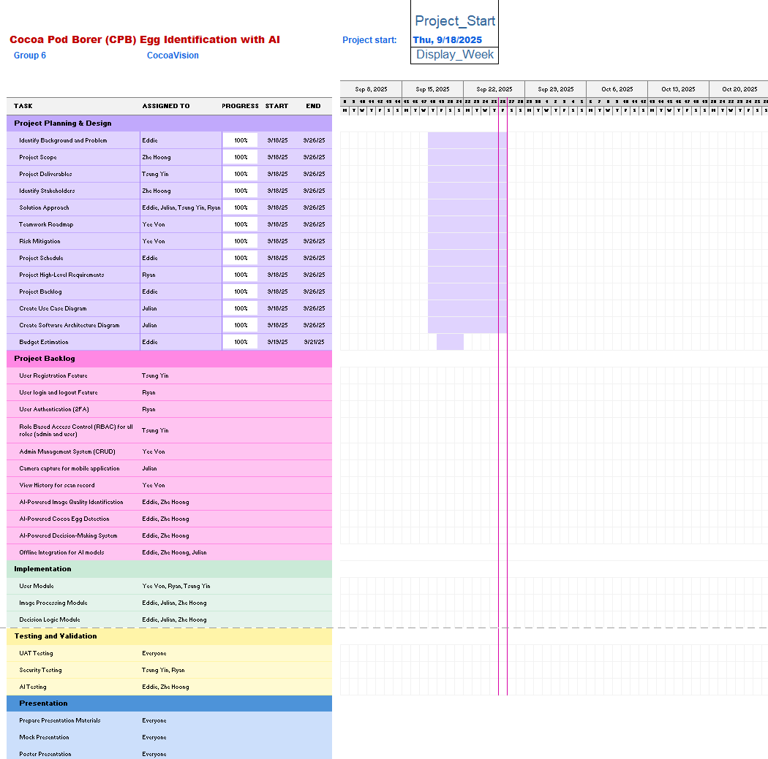

The project is organised into five phases using a Gantt Chart to ensure a manageable and clear progression from planning to completion.
The Planning and Design Phase of the project begins by defining key elements such as the background and problem statement, project scope including both in-scope and out-of-scope, stakeholders, and deliverables. This phase also includes high-level requirements, initial project backlog, and the solution approach which includes the system architecture and use case diagrams, which includes the system architecture and use case diagrams. In addition, the roadmap for teamwork, document management strategy, and risk mitigation plans are established to ensure clarity and alignment throughout the project.
Moving on from the initial planning phase, the project backlog phase is dedicated to laying out the specific features that will be developed for the DMCOCOA mobile application system. For the functionalities in the application, it includes User Registration, Login/Logout, User Authentication (2FA), Role-Based Access Control (RBAC), and an Admin Management System (CRUD). Simultaneously, the specifications for the AI and mobile components will be specified, covering the mobile camera capture feature, the scan history view, and the core AI capabilities that are, Image Quality Identification, Cocoa Egg Detection, the Decision-Making System, and their Offline Integration.
The Implementation Phase involves the development of core system modules based on the defined requirements and architecture. These include the user module which involves the development of all the functionalities that will be user-centric, it includes authentication, profile management, and all other essential functions needed for the project. Next will be the image processing module. This module involves the implementation of the mobile camera interface with the integration of AI models for image analysis, here being especially the quality of pictures taken and also the counting of cocoa pod borer eggs. Last will be the decision logic module that processes the previous AI outputs for decision-making, here being the final decision of whether to spray or not to spray pesticides according to the Economic Threshold Level (ETL).
The Testing Phase emphasizes ensuring system functionality, usability, and performance. User Acceptance Testing (UAT) is to be conducted to validate the system against stakeholder needs and confirm that the project deliverables meet the agreed definition of done. Then, security testing will be carried out to ensure the application and its data are secure. AI testing to validate the accuracy, performance, and reliability of the AI model.
Finally, it will be the presentation phase. This phase focuses on preparing and communicating the project outcomes. At the end, a poster presentation will be held on campus to stakeholders.

High-level requirements
Context of the System
The proposed system for Lembaga Koko Malaysia (MCB) is a new and complete solution designed to enhance the project collaboration, it is not an upgrade of an existing product but rather a purpose-built system aimed at improving efficiency, collaboration and reporting.

A central feature of the system is the AI-based image recognition to scan cocoa pods and detect the presence of insect eggs. The AI-powered scanning function is to support cocoa farmers, researchers and stakeholders in early pest detection, thereby improving yield quality and reducing crop losses.

The system forms part of a broader digital ecosystem within MCB, incorporating modern AI techniques. The mobile application will serve as a standalone tool, while also functioning as a component of a broader agricultural management ecosystem that could include analytics dashboards and maybe expandable to integrate with future enterprises.

5.1 Functional Requirement
AI Scanning Module
- The system must allow users to capture or upload images of cocoa pods via a mobile app.
- The AI model must process the image and detect the presence of eggs on the pod surface.
- The system display results (e.g., “3 Eggs Detected” / “No Eggs Detected”).

Mobile Application
- Must provide a user-friendly interface for farmers and stakeholders.
- Must include login and role-based access (farmer, researcher, admin).
- Must allow offline image capture, with processing either offline (device-level AI) or online (cloud-based AI).

Data Management
- Images and results must be stored in a structured database.
- The system must allow retrieval of historical scans for analysis.
- Must provide export functionality for reports.

Integration
- The system should be integrated with a dashboard for MCB researchers.

5.2 Non-Functional Requirement
Performance
- AI detection must process images in under 5 seconds per scan.
- The system must handle at least 100 concurrent users during peak usage.

Accuracy
- AI scanning must achieve a minimum accuracy of 85% in egg detection, with continuous model retraining planned to improve performance.

Usability
- The mobile interface must be intuitive and accessible to users with minimal technical background.
- Must support multi-language interface (English, Bahasa Malaysia, and potentially other local languages).

Reliability & Availability
- System uptime must be at least 99%.
- Offline functionality should allow image storage for later processing when internet is unavailable.

Security
- User data and captured images must be encrypted.
- Must comply with Malaysia’s PDPA (Personal Data Protection Act) standards.
- Ensure that only authorized users of the application are allowed to access certain sensitive content.
- Enforce Role-Based Access Control in the system to maintain the segregation between the admin and cocoa farmers in the sense that only admin is allowed to view farmers’ personal information and manage them.

Scalability
- The system must allow for future integration of other AI features, such as disease detection or cocoa quality assessment.

Solution Approach

6.1 Software Development
Two solutions were proposed to implement the software development section of the DMCOCOA mobile application for cocoa farmers and staff involved.
Solution 1: Native Mobile Development (Kotlin for Android, Swift for iOS) with On-Device AI
This solution involves developing a standalone mobile application for Android and iOS using their respective native languages. The AI model would be integrated directly into the app, allowing for on-device processing without the need for a constant internet connection, which is crucial for farms with limited connectivity. A lightweight backend (e.g., Firebase) could be added for optional features like data syncing.
Solution 2: Cross-Platform Development (Flutter with On-Device AI & Firebase)
This solution involves building a single codebase for both Android and iOS using the Flutter framework. The core AI model for egg detection is packaged within the app for instant, offline processing. Firebase is used as a Backend-as-a-Service (BaaS) to handle authentication, cloud data storage, and offline synchronization for user profiles and scan history, providing a seamless online/offline experience.
Table 6: Software Development Solution Approach
 | KOST Analysis | SWOT Analysis | Final Verdict
Solution 1: Native Mobile Development (Kotlin for Android, Swift for iOS) with On-Device AI | Knowledge Gap  The team has limited experience with native mobile development for both Android and iOS simultaneously. Integrating the AI model for on-device inference is a new challenge.  Skill Gap  While some members have general mobile development knowledge, deep expertise in Kotlin and Swift is limited. Developing and maintaining two separate codebases for Android and iOS will require a broader skill set and more effort.  Technology Gap  Ensuring consistent performance and feature parity across two different native platforms can be technologically challenging. On-device AI model inference requires optimization for different hardware capabilities. | Strengths  Superior performance, direct access to native device features (camera), and can work fully offline, a critical feature for rural farms.  Weaknesses  Longer development time due to separate codebases, requires expertise in two different programming languages, higher long-term maintenance cost.  Opportunities  Provides a high-performance, reliable user experience that closely mimics the existing DMCOCOA app.  Threats  The development complexity could lead to delays, and the team may struggle to achieve proficiency in both native environments simultaneously. | Rejected
Solution 2: Cross-Platform (Flutter + Django + Firebase) | Knowledge Gap  The team needs to learn Flutter's app structure and how to integrate a TensorFlow Lite model for on-device inference. Firebase is new but well-documented.  Skill Gap  The team has relevant frontend experience (JavaScript, Vue.js) that eases learning Flutter. Experience with Python-based AI development is a strength.  Technology Gap  Integrating on-device AI into Flutter is straightforward using the tflite_flutter package. Firebase provides a robust and simple solution for backend needs. | Strengths  Single codebase for both platforms; faster development cycle; true offline capability for AI detection; simpler backend management with Firebase; easier maintenance and updates.  Weaknesses  AI model performance may be slightly less optimal than native for extremely complex models, though sufficient for this use case.  Opportunity  Enables rapid prototyping and iteration; scalable architecture; easy to add features like real-time data sync and cross-device history.  Threats  The learning curve for new technologies (Flutter, Firebase) might impact initial progress, but this is manageable. | Accepted
Proposed Solution Direction and Justifications:
The decision is to proceed with Revised Solution 2 (Flutter with On-Device AI & Firebase) for the following reasons:
- Critical Offline Functionality Achieved: By bundling the AI model directly into the Flutter app, we achieve the essential requirement of full offline operation for egg detection, addressing the core need for use in rural farms. This corrects the major flaw in the initial analysis.
- Development Efficiency & Maintainability: Flutter's single codebase approach significantly reduces development and maintenance effort compared to managing two native codebases, allowing the team to focus on application logic and user experience.
- Optimal Backend Solution: Firebase is the correct choice for this project's scale, providing pre-built, secure, and offline-capable services for authentication and data storage, eliminating the need for a complex custom Django backend for these standard functions.
- Team Skill Alignment: The team's existing frontend experience facilitates learning Flutter. The core challenge of model training remains in Python, aligning with the team's AI skills.
- Cost-Effectiveness and Scalability: This architecture is more sustainable for a proof-of-concept project, reducing initial development time and long-term maintenance costs, while allowing for easy future expansion using Firebase services.

6.2 Artificial Intelligent
Two solutions were proposed to integrate the artificial intelligence section of the DMCOCOA mobile application for cocoa farmers and staff involved.
Solution 1: Use pre-built model
To let the user be able to identify the number of eggs on cocoa pods and determine image quality (good vs bad), the solution will involve developing two models using pre-trained architectures.
            - An object detection model such as YOLO for detecting and counting eggs on cocoa pods
            - A classification model such as CNN for determining image quality
Solution 2: Create A New Model from Scratch
To let the user be able to identify the number of eggs on cocoa pods and determine image quality (good vs bad), the solution involves developing custom deep learning model from scratch. Instead of leveraging pre-built models, a unique model will be designed, trained and optimized specifically for the tasks
Table 7: Artificial Intelligent Solution Approach
 | Kost Analysis | SWOT Analysis | Final Verdict
Solution 1: Use pre-built model | Knowledge Gap  The team doesn't know the cocoa pod borer eggs characteristics. It creates a knowledge gap while collecting the data that is needed to identify cocoa eggs on the cocoa pod.  Skill Gap  The team has experience on building classification models and object detection models. However, the team is still in the early stage of building classification models and object detection models. To address the skill gap, the team needs to explore more about building classification models and object detection models.  Technology Gap  There is a technology gap for this solution because it requires a good understanding of the technology that needs to be used to build the classification models and object detection models. The team might face challenges related to data collection and processing due to limitations in hardware or software. To bridge the gap, the team needs to explore suitable technologies to build classification models and object detection models. | Strengths  The team has experience in building classification models and object detection models.  Weakness  Still on early stage of building classification models and object detection models  Opportunity  Explore deeper by building classification models and object detection models.  Threats  Increased learning curve might delay the development phase. | Accepted
Solution 2: Create A New Model from Scratch | Knowledge Gap  The team doesn't know the cocoa pod borer eggs characteristics. It creates a knowledge gap while collecting the data that is needed to identify cocoa eggs on the cocoa pod.  Skill Gap  The team doesn't have any experience on building classification models and object detection models from scratch. To address the skill gap, the team needs to explore more about building classification models and object detection models from scratch  Technology Gap  There is a technology gap for this solution because it requires a good understanding of the technology that needs to be used to build the classification models and object detection models. The team might face challenges related to data collection and processing due to limitations in hardware or software. To bridge the gap, the team needs to explore suitable technologies to build classification models and object detection models. | Strengths  The team has experience in building classification models and object detection models using pre-built models.  Weakness  No experience on building model from scratch  Opportunity  Learn the way to build classification models and object detection models from scratch  Threats  The model may not perform as well as a pre-built model. Increased learning curve might delay the development phase. | Rejected

Proposed Solution Direction and Justifications
The team will proceed with Solution 1: Using a pre-trained model for the AI component of the CPB egg detection system. Specifically, we will leverage a state-of-the-art pre-trained object detection architecture like YOLO (You Only Look Once) or a pre-trained CNN backbone, which will be fine-tuned on our custom dataset of annotated cocoa pod images.
Justifications:
- Project Timeline and Practicality: Building a model from scratch (Solution 2) is a complex, research-oriented process that requires extensive time, data, and computational resources. For a proof-of-concept project with a defined timeline, transfer learning (using a pre-trained model) is the industry-standard, pragmatic approach. It allows us to achieve a functional and accurate model much faster by building upon knowledge already learned from large-scale datasets like ImageNet.
- Mitigation of Data Scarcity: CPB eggs are a highly specific subject with limited available imagery. Pre-trained models have already learned universal features like edges, textures, and shapes from millions of images. By fine-tuning, we effectively "teach" this general-purpose model to specialize in identifying CPB eggs with a relatively small dataset, overcoming the significant challenge of data scarcity that would cripple a from-scratch model.
- Alignment with Team Skill Level: The team has foundational experience in building classification and object detection models, which is perfectly suited to the task of fine-tuning a pre-trained model. Solution 2 (building from scratch) presents a steep learning curve in advanced neural network architecture design, weight initialization, and prolonged training cycles—skills beyond the current scope and which pose a high risk of project delays.
- Proven Performance and Reliability: Architectures like YOLO are battle-tested for real-time object detection and are known to achieve high accuracy efficiently. This reduces the technical risk compared to the uncertainty of whether a custom-built model (Solution 2) would converge effectively or generalize well to real-world conditions.
- Focus on Application Integration: The primary project goal is to integrate a working AI system into a mobile application. Solution 1 provides a clear, reliable path to a production-ready model that can be converted to a mobile-friendly format (e.g., TensorFlow Lite). This allows the team to allocate more time to the critical tasks of system integration, user interface design, and testing, rather than on foundational AI research.

6.3 Data Science
Two solutions were proposed to improve the data science section of the DMCOCOA mobile application for cocoa farmers and staff involved.
Solution 1: Manual Data Annotation with Basic Augmentation
This approach involves manually labelling CPB eggs in images using annotation tools (e.g., Labelling, CVAT) with guidance from domain experts at Lembaga Koko Malaysia. Basic data augmentation techniques (rotation, flipping, brightness adjustment) will be applied to increase dataset size and variability. A structured dataset repository will be maintained with version control to track annotations and model training cycles.
Solution 2: Semi-Automated Annotation with Advanced Augmentation and Synthetic Data
This approach combines manual labelling with pre-labelling using a preliminary model to speed up annotation. Advanced augmentation techniques (e.g., random erasing, mix-up, cut mix) and synthetic data generation (using GANs or style transfer) will be used to enhance dataset diversity and size. A data pipeline will be built to automate augmentation, validation, and versioning of datasets.
Table 8: Data Science Solution Approach
Aspect | KOST Analysis | SWOT Analysis | Final Verdict
Solution 1: Manual Data Annotation with Basic Augmentation | Knowledge Gap  Team understands basic annotation and augmentation concepts but lacks experience in agricultural image specificity and consistency in labeling.  Skill Gap  Team has basic Python and OpenCV skills for augmentation but may struggle with large-scale data management and versioning.  Technology Gap  Relies on open-source tools; may face challenges with annotation consistency and scalability. | Strengths  Simple to implement, full control over labeling quality, low initial complexity.  Weaknesses  Time-consuming, prone to human error, limited dataset diversity.  Opportunities  Close collaboration with domain experts ensures label accuracy.  Threats  Dataset may be too small or biased, leading to poor model generalization. | Accepted
Solution 2: Semi-Automated Annotation with Advanced Augmentation and Synthetic Data | Knowledge Gap  Team is unfamiliar with synthetic data generation and advanced augmentation methods.  Skill Gap  Limited experience with GANs, advanced augmentation pipelines, or automated labeling tools.  Technology Gap  Requires more computational resources and expertise in generative models. | Strengths  Faster annotation, larger and more diverse dataset, better model robustness.  Weaknesses  High complexity, risk of introducing unrealistic data, requires more validation.  Opportunities  Potential for highly generalized model, reduced manual effort over time.  Threats  May overcomplicate the project timeline and require expertise beyond current capacity. | Rejected

Proposed Solution Direction and Justifications
The team has decided to proceed with Solution 1 (Manual Data Annotation with Basic Augmentation) for the following reasons:
- Alignment with Project Timeline: Manual annotation is more predictable and manageable within the project’s proof-of-concept scope.
- Expert Collaboration: Direct involvement with Lembaga Koko Malaysia ensures labelling accuracy and domain relevance.
- Low Risk: Avoids the complexity and potential pitfalls of synthetic data and advanced augmentation, which could delay model training.
- Foundation for Iteration: A clean, manually curated dataset can serve as a reliable baseline for future improvements or semi-automated approaches.
Implementation Roadmap: The process will involve data acquisition, tool setup (e.g., Roboflow), guideline development with experts, a quality assurance protocol, basic augmentation (rotations, flips, lighting changes), and dataset versioning using DVC.
This approach ensures that the AI model is trained on high-quality, expert-verified data, which is critical for achieving the target accuracy around 80% to 85% in CPB egg detection.

6.4 Cybersecurity
Two solutions were proposed to improve the cybersecurity of the DMCOCOA mobile application for cocoa farmers and staff involved.

Solution 1: 2FA (Two-Factor Authentication with Google Authenticator) and RBAC (Role-Based Access Control)
- 2FA with Google Authenticator: Two-Factor Authentication (2FA) specifically enhances login security by requiring two separate forms of verification. In this case, the system will pair the user’s account password with a time-based one-time password (OTP) generated by Google Authenticator. Once 2FA is enabled, users will need to enter their password and then a 6-digit code displayed on the Google Authenticator app, which refreshes every 30 seconds. This method ensures that even if an attacker gains access to the user’s password, they cannot log in without also possessing the user’s registered mobile device. The simplicity of an app like Google Authenticator makes it easy, reliable and practical for farmers and admins to safeguard their accounts.

- RBAC: Users will be assigned their respective roles in this system. Namely, admin and cocoa farmer. This is ensuring the different roles have different access to certain content within the application. Generally speaking, an admin has the highest authority and has access to the insights of the application. This includes managing users, getting AI model updates, or getting a visualisation of the statistics by the data input collected through the AI imaging on the amount of cocoa pod borer larvae scanned on each cocoa pod. On the other hand, cocoa farmers have restricted access to sensitive data. Besides general functions like viewing their own profile, they are allowed to only use the camera scanner and yield records.

Solution 2: MFA (Multi-Factor Authentication) with ACL (Access Control List)
- MFA: Multi-Factor Authentication is an additional layer of security that requires users to provide two or more independent factors to verify their users before accessing the system. These factors could include something the user knows like a password or PIN, or even something unique the user has (biometric data such as fingerprint or facial recognition). By combining multiple verification factors, MFA significantly reduces the risk of unauthorized access

- ACL: An Access Control List (ACL) is a list of set of rules attached to an individual resource (a file, a database, a folder, etc.) in the system. This list of rules will be defining which users can access the resource and what actions they are allowed to carry out (edit, view, delete, etc.). In this context, resources could be farmers’ yield records, pesticide spraying recommendations, mobile app user list, and cocoa pod scan images.
Table 9: Cybersecurity Solution Approach
 | KWOST | SWOT | Final Verdict
Solution 1 | Knowledge Gap  The team understands 2FA basics but will need to learn how does Google Authenticator (TOTP) works and how to integrate it into a mobile application. Besides that, the team has experience in RBAC integration on web applications and needs to start learning mobile app integration from scratch.  Skill Gap  The team will have to explore the integration of both 2FA and RBAC into mobile applications as it is more challenging but doable.  Technology Gap  Backend setup for TOTP and RBAC will be on the complex side for a large-scale system. | Strengths  The team has basic experience working with the implementation of 2FA in web applications and is familiar with basic role-based access control implementation.  Weaknesses  Lack experience in integrating 2FA and RBAC into a mobile application.  Opportunity  The team will get a chance to explore the mobile application domain and basically start learning a whole new skill.  Threat  Potential inconvenience may occur for developers as 2FA may bring complications. RBAC mistakes, while rarely happening, may bring complications if a role is not correctly defined. | Accepted
Solution 2 | Knowledge Gap  The team has basic knowledge on MFAs but do not have the experience of implementing various authentication methods at once, not to mention on mobile applications. The ACL concept is also understood by the team, but not much on the implementation part.  Skill Gap  The team has limited skills in the designing of MFA workflows and the implementation of both MFA and ACL in mobile applications.  Technology Gap  There is a high level of complexity in scaling ACL across many users and records. On the other hand, there will be complications with device support if MFA with biometrics is set up. | Strengths  The team has a grasp on the concept of both MFA and ACLs.  Weaknesses  No experience in the implementation of MFA and ACL into either web applications or mobile applications.  Opportunity  Get to acquire skills in applying both MFA and ACL to systems as they require much more knowledge and technical skills.  Threat  Prone to misconfiguration as MFA involves multiple factors of authentication. ACL is also prone to complications, especially when the list of users keeps on increasing. | Rejected

Proposed Solution Direction and Justifications
The team has agreed to pursue 2FA with Google Authenticator and Role-based Access Control (RBAC) for the DMCOCOA mobile application. This decision was made as Google Authenticator provides a secure, offline-friendly two factor authentication method as compared to the more-complex multi-factor authentication method. As for the chosen RBAC method, it is much simpler by assigning roles to users with their respective access, rather than using ACLs that are far more complicated and the potential risk of complications when number of users increases. This approach offers simpler usability and strong protection to the system, aligning with the needs of users within the system while still maintaining system flexibility and security.

System diagram

7.1 Architecture Diagram
Diagram 2: Architecture Diagram
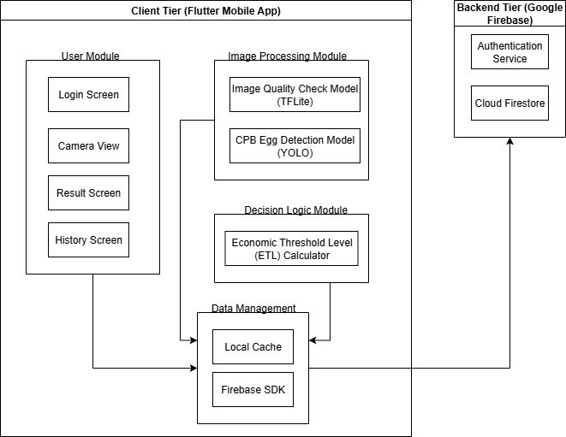
Client Tier (Flutter Mobile App)
Role: This tier is the standalone mobile application installed on the user's device. It serves as the complete interface for the cocoa farmer and contains the core intelligence of the system.
Key Functions:
- User Interaction: Provides all screens for login, camera capture, viewing results, and history through an intuitive UI.
- Core Processing: Hosts the On-Device AI Engine, which performs both image quality checks and CPB egg detection instantly on the device.
- Business Logic: Contains the Decision Logic Module that applies the Economic Threshold Level (ETL) to generate the "Spray/Do Not Spray/Monitor after 10 days" recommendation locally.
- Offline Operation: The entire tier is designed to operate within an "Offline Capability Boundary", meaning all critical functions from image capture to result generation work without an internet connection. Data is cached locally and synced with the cloud when available.
Justification: By moving the AI processing and decision logic to the client, the crucial requirement of offline functionality for use in rural farms is achieved with minimal latency and no dependency on network reliability.

Backend Tier (Google Firebase)
Role: This tier provides managed cloud services that support the mobile app. It handles user management and data persistence without requiring a custom-built backend server.
Key Functions:
- Authentication Service: Securely manages user accounts, login sessions, and Two-Factor Authentication (2FA) via Google Authenticator.
- Cloud Firestore: Acts as the primary cloud database, storing user profiles and a synchronized history of all scan records. This allows farmers to access their history from any device.
- Data Synchronization: Provides seamless synchronization between the local cache on the mobile app and the cloud database. When the app is online, data is automatically synced, ensuring consistency.
Justification: Using Firebase as a Backend-as-a-Service (BaaS) simplifies development, reduces maintenance overhead, and provides robust, scalable services for authentication and data storage that are perfectly suited for a mobile application of this scale.

7.2 Use Case Diagram
The use case diagram illustrates the functionalities of two main roles: Admin and Users. The admin manages user accounts and database while the user can upload cocoa pod photos to the database and view the upload records from the database. Both roles have access to common functionalities such as sign up, login and logout.
Diagram 3: Use Case Diagram
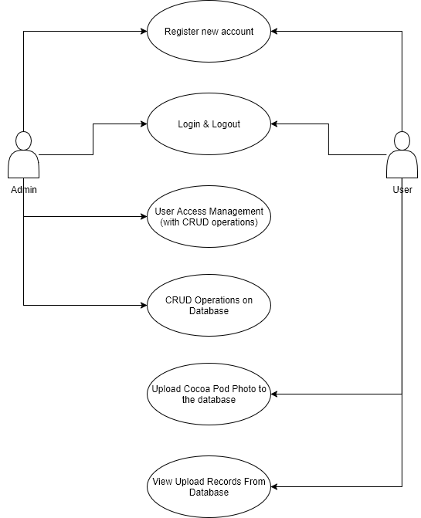

7.3 Process Flow Diagram
Diagram 4: Process Flow Diagram
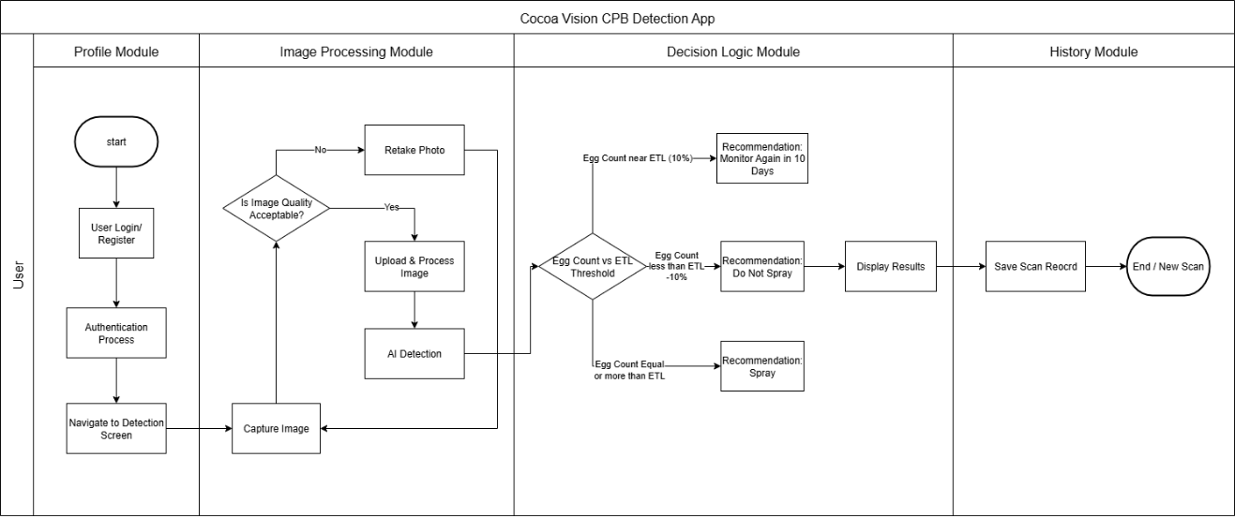
The process flow diagram illustrates the step-by-step interaction between the cocoa farmer (user) and the Cocoa Vision system to perform a CPB egg detection scan and receive a spraying recommendation. The workflow begins with the user launching the application and authenticating to ensure data security and personalization. After navigating to the detection screen, the user captures an image of a cocoa pod. The system first checks the image for basic quality to ensure it is suitable for analysis. If the quality is poor, the user is prompted to retake the photo.
Once a suitable image is captured, it is uploaded to the backend server. The backend then forwards the image to the dedicated AI service for processing. The AI model analyses the image to identify, count, and locate any CPB eggs present. This count is returned to the backend, where the core business logic is applied: the system compares the egg count against the pre-defined Economic Threshold Level (ETL). Based on this comparison, one of three clear recommendations is generated: Spray (if the count meets or exceeds the ETL), Do Not Spray (if the count is below the threshold), or Monitor Again (if the count is near the threshold, suggesting a re-check after a set period).
This final recommendation, along with the egg count and processed image (often with visual bounding boxes), is then sent back and displayed to the user on the mobile app. Simultaneously, the record of this scan—including all relevant data—is saved to the database for the user's future reference and historical tracking. The process concludes by allowing the user to perform another scan, creating a seamless and efficient loop for ongoing pest management. This automated flow replaces the manual, error-prone sequential sampling process described by the client, providing farmers with a rapid, data-driven decision-making tool.

Product backlog
The Product Backlog provides a prioritized list of features, enhancements, and tasks required to deliver the CPB egg detection mobile application. It serves as a dynamic roadmap for the development team, outlining key functionalities such as user authentication, AI-powered detection, and administrative controls. Each backlog item includes details on business value, dependencies, and the expected sprint for release, ensuring alignment with project objectives and stakeholder expectations.
Table 10: Product Backlog
Product Backlog No: | Product Backlog Items | Business Value | Dependencies | Expected Sprint Release
 | User Registration Feature | High | None | 2
 | User login and logout Feature | High | 1 | 2
 | User Authentication (2FA) | High | 2 | 2
 | Role Based Access Control (RBAC) for all roles (admin and user) | High | 2 | 2
 | Admin Management System (CRUD) | High | 2 | 2
 | Camera capture for mobile application | High | 2 | 2
 | View History for scan record | High | 2, 9 | 2
 | AI-Powered Image Quality Identification | High | 6 | 2
 | AI-Powered Cocoa Pod Borer Egg Detection | High | 6 | 1
 | AI-Powered Decision-Making System | High | 9 | 2
 | Offline Integration for AI models | High | 6, 8, 9 | 3

Quality plan
The Quality Plan outlines the systematic approach to ensuring that the delivered system meets defined quality standards and functional requirements. Based on the ISO25010 quality model, it maps each product backlog item to specific quality characteristics such as functionality, security, and reliability and defines target expectations along with steps to validate them. This plan ensures that all features are thoroughly tested and evaluated before release, supporting the goal of delivering a robust, user-friendly, and reliable solution for cocoa farmers.
Table 11: Quality Plan
Product Backlog No: | Product Backlog Items | Main Characteristics | Sub-Characteristics | Target Quality Expectation | Steps to assure quality
 | User Registration Feature | Functionality  Suitability | Functional Completeness, Functional Correctness | User account is created successfully in Firebase upon valid input. | Unit & Integration Testing: Test with valid/invalid emails, weak passwords. Verify data persists in Firestore.
 | User login and logout Feature | Functionality  Suitability | Functional Completeness, Functional Correctness | User gains access only with correct credentials. Session is securely terminated on logout. | Integration Testing: Test login success/failure. Verify session tokens.
 | User Authentication (2FA) | Security | Authentication | Login is blocked without the correct Time-based OTP (TOTP) from Google Authenticator. | Integration Testing: Test the TOTP verification flow with valid and invalid codes.
 | Role Based Access Control (RBAC) for all roles (admin and user) | Security | Authentication | Role-based access control ensures different content will only be accessed by certain roles (admin, users) | System Testing: Verify RBAC rules
 | Admin Management System (CRUD) | Functionality  Suitability | Functional Completeness, Functional Correctness | Admin is allowed to create, read, update and delete registered users’ information. | System Testing: test all CRUD operations from an admin account.
 | Camera Capture for mobile application | Functionality  Suitability | Functional Completeness | The app successfully accesses the device camera and captures a photo of a cocoa pod. | Usability Testing (UAT): Test on real devices. Ensure the interface is intuitive for farmers.
 | Scan History | Functionality, Reliability | Suitability, Recoverability | All past scans are saved and retrievable, syncing between devices when online. | Integration Testing: Verify scans are saved locally and synced to Firestore. Test history view under offline/online conditions.
 | AI-Powered Image Quality Identification | Functionality Suitability | Functional Correctness | The model correctly identifies blurry/unsuitable images with ≥90% accuracy, prompting a retake. | Model Evaluation: Use a separate validation dataset of "good" and "bad" images to measure precision/recall.
 | AI-Powered Cocoa Egg Detection | Functionality Suitability | Functional Correctness | The object detection model achieves a mAP (mean Average Precision) of ≥0.85 on a test dataset. | Model Evaluation: Benchmark model performance on a held-out test set of annotated cocoa pod images.
 | Decision-Making Logic | Functionality Suitability | Functional Correctness | The recommendation (Spray/Do Not Spray/Monitor) is 100% consistent with the predefined Economic Threshold Level (ETL). | Unit Testing: Test the logic function with various input egg counts to ensure the output matches the ETL rules.
 | Offline Functionality | Reliability | Fault Tolerance | All core features (capture, AI detection, recommendation) work without an internet connection. | System Testing: Test the app's core workflow in Airplane Mode. Verify data syncs once connectivity is restored.

10. Resources

10.1 Hardware
The hardware used in this project is mostly for equipment only, listed below:
Table 12: Estimated Budget of the Hardware Components to Be Used
No. | Hardware Components | Price (RM) | Quantity | Total (RM) | References
1 | Phone Camera Lens | 56.74 | 1 | 56.74 | Click here
Grand Total |  |  |  | 56.74 | -

10.2 Software Stack
The software stack used in this project includes:
Core Development
- VS Code (primary IDE)
- Git + GitHub/GitLab (version control)
- Flutter SDK (mobile development)
- Android Studio (emulator/testing)
- Python + Django (backend + AI)
AI/Data Science
- Google Collab (cloud experimentation)
- Jupyter Notebook (local development)
- Roboflow (data annotation & management)
- Albumentations/OpenCV (data augmentation)
Design & Documentation
- Figma (UI/UX design)
- Draw.io (architecture diagrams)
- Microsoft Word (reports)
- Microsoft Excel (Gantt charts, data analysis)
- Power BI/Tableau (Data Visualization)
Project Management
- Trello (task management)
- Google Drive (file storage)
- Microsoft Teams/Discord/WhatsApp (communication)
Testing & Deployment
- Postman (API testing)
- Firebase Console (Using Firebase services)
- Google Play Console (app deployment)

11. Approval Signatures:
Project Team
 | Name of student | Student Id | Signature | Roles
1 | Eddie Yung Yew PUI | 104386199 |  | Team Leader/ Product Owner
2 | Julian Chet Shiang JEE | 102772505 |  | Scrum Master/Developer
3 | Tsung Yin NG | 102772686 |  | Meeting Minutes Taker/ Developer
4 | Yee Von LOW | 102774187 |  | Developer
5 | Zhe Hong VOONG | 102785862 |  | Developer
6 | Ryan NG Hoe Kuene | 102784513 |  | Developer

Project Sponsor
Person In Charge | Signature:
Mr Felix | 
Dr. Brian

